GREEN NATIONAL MODEL HIGH SCHOOL ADILPUR
CLASS: KG _{1st} _{TERM EXAMINATION 2024-25} _{SUBJECT: MATHEMATICS}
DATE://2024 _{TIME ALLOWED 3 HOURS} MAX MARKS: 50

Seat No: ______________ Signature: _______________

Q: 1 Write the numbers from 1 to 20?

Q: 2 Write the Spellings from 1 to 7?
_________________________________________________________________________________________________________________________________________________________________
_________________________________________________________________________________________________________________________________________________________________
_________________________________________________________________________________________________________________________________________________________________
_________________________________________________________________________________________________________________________________________________________________

_________________________________________________________________________________________________________________________________________________________________
_________________________________________________________________________________________________________________________________________________________________
_________________________________________________________________________________________________________________________________________________________________
_________________________________________________________________________________________________________________________________________________________________

Q: 3 Write the missing numbers?

4 |  |  | 7 |  | 9 | 10 |  |  | 13 | 14

Q: 4 Write the missing words:
T____ree F___ve Si_____ Se____en
Q: 4 Match the following .
- Two
- Five
- Four
- Three
- One
Q: 5 Circle the 3 digit number:
3
1 7 9
8 4 3 8
4 9 2 3
6 2 3 1

Q:6 Write the names of shape

__________________ ________________

Q:7 Count and write:

___________________

___________________

____________________

Q:8 Connect dots and fill in the cloures.

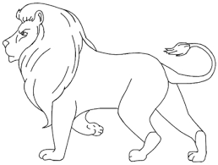

THE END

